Welcome to Assemble
Assemble is the new way to manage your volunteering at St Pauls Cathedral. It is an online system that allows you to communicate more easily with your team and other volunteers. You will be able to keep up to date with news about the cathedral and find all the documents and information you may need for your volunteering. You can also keep track of your own training information.

We are here to support you, if you have any questions please do get in touch at volunteering@stpaulscathedral.org.uk

Accessing Assemble
Logging in and changing your password.
You will have received a welcome email with a temporary password – just like the one shown below.

Welcome to Assemble
Dear Marcelo,
We're delighted to welcome you to Assemble.
Just click on this link and log into our volunteer website using the password "LeaveApply795".
There you can contact other volunteers, share ideas and skills and join in discussions. You will also be able to keep up to date with news about St Pauls Cathedral and find all the documents and information you may need.
Your details are held securely and with the Message Centre, no-one will know your email address. Just look at My Details to update or add any information you want.
We hope that Assemble will really help you in your volunteering role and you will enjoy the opportunity to make links with fellow volunteers across the UK.
If you do have any questions, please do click the Ask Us button and we will be happy to help.
Best wishes Volunteering Department

To change the password, click on the link and log in using your email address and the temporary password.

Once you have signed in using the temporary password, you can change your password to something you pick. The change password page will automatically appear, and you will be prompted to choose a new password, re-enter it to confirm and click “change Password”

You will be able to log on with your email address and this new password in future. If you forget your password, you can enter your email address and get a password reset link sent to you

As part of logging in you may occasionally be asked to enter a six-digit code and enter it to proceed. Check your email (including your spam folder) for the code and enter it to proceed. Ticking the “trust this device” box will reduce the number of times you need to enter the code, but only do this on a private device and do not tick the box if you are using a shared computer.

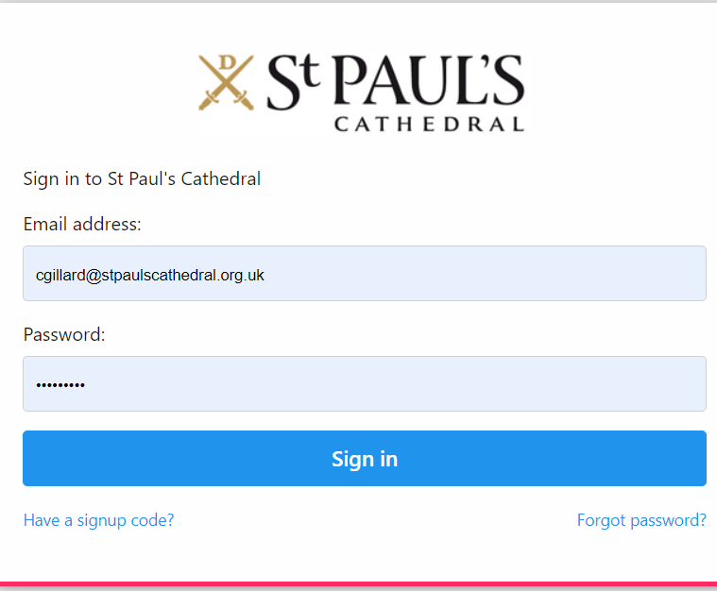
Logging in for the first time is covered above, but to access the system please visit:
https://st-pauls-cathedral.goassemble.com/portal/home

We recommend you bookmark it so you can easily find it.

When you’re logged in you’ll automatically come to the Assemble Home page.
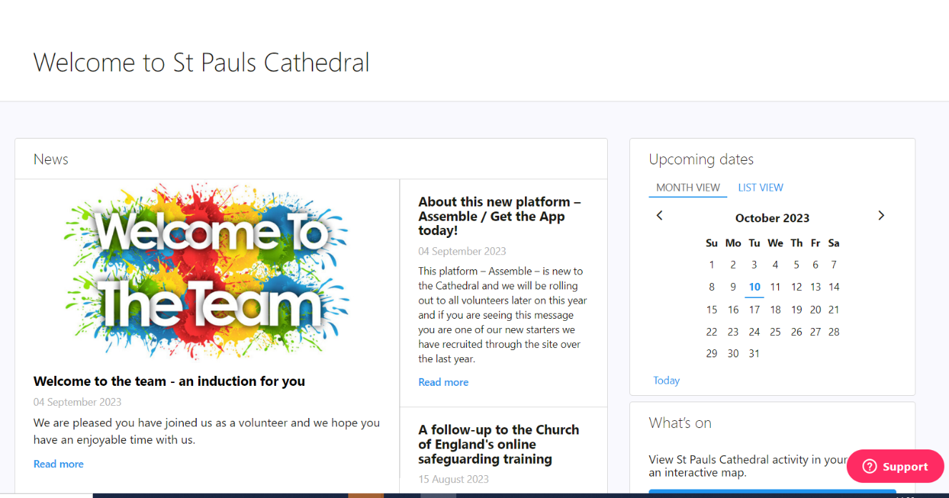

This is the main menu where you can navigate to different options, including news, calendar, and latest opportunities. If you scroll down the page, you will see the twitter and Facebook feeds for the cathedral.

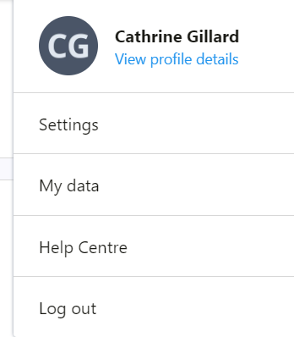
On the left of the page, you will see an item called document hub- if you click here, you will be able to see the documents for your team, we will populate these with more information as we move all our volunteers onto the system.

Viewing you volunteer profile
Once you have logged in, you can view your personal volunteer profile by clicking on the circle showing your initials in the top right-hand corner of the screen and selecting “View profile details” under your name.

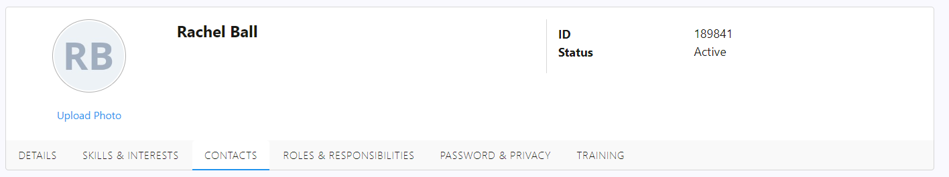
Your profile is split into six main tabs:
- Details
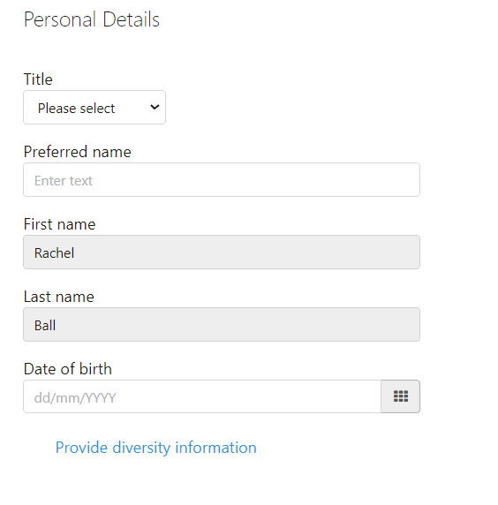
On the details tab can you please check that your name, date of birth and start date are correct. We do not have accurate start dates for everyone as you are not able to amend this, please let us know the correct date if necessary.

You can also add your reasons for volunteering and a little about yourself if you wish.

If you have any accessibility requirements, please add them to the “accessibility and special requirements field”. Please leave blank if you do not have any requirements.

Underneath your date of birth field you can update your diversity information, this is only collected at an aggregated level so no one from the cathedral can see the details.
- Skills & interests
If you speak any other languages, please enter details here

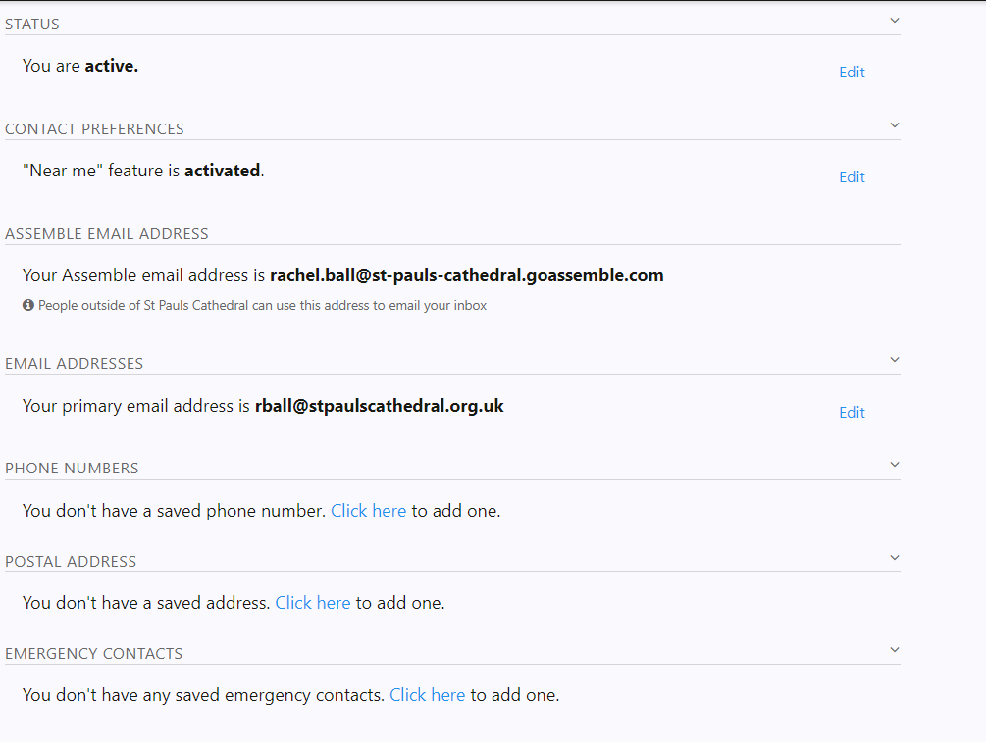
- Contacts
Please check and update your home address, e-mail address and phone number and add an emergency contact name and number.

- Roles and responsibilities
These should reflect your volunteering role, if you are a member of multiple teams you may need to let us know to update

- Password and Privacy

- Training
This tab will show you what training you need to undertake and when it is due for renewal.

Let us know you have accessed your account
This short form will help us to see you have reviewed your profile and enable us to make the changes you cannot, please complete after you have reviewed your profile. Assemble User Details

