**Bizarre content going missing**

**Thursday – what’s on disappeared**

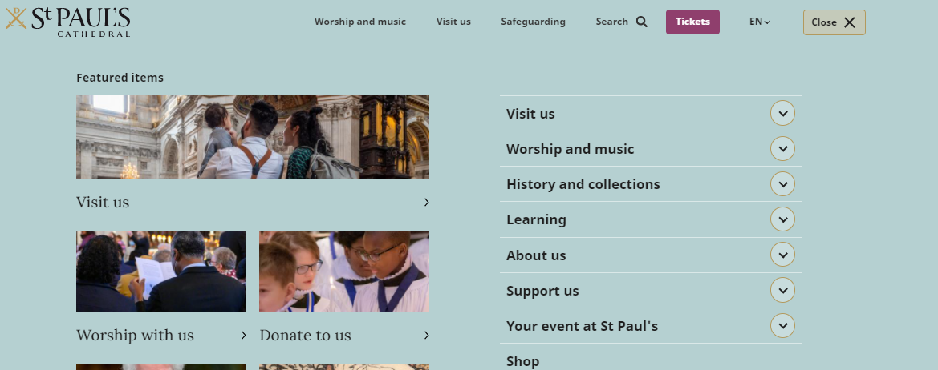

**Wedsnesday – Learning Library image disappear**

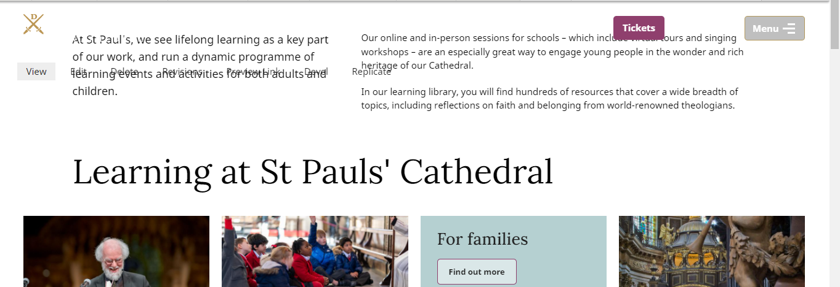

**Changes by admin:** 